References:

* <https://aqicn.org/city/dhaka/>
* <https://www.iqair.com/us/bangladesh/dhaka>

For the correct knowledge of the AQI data of Dhaka city, Bangladesh and their current position in the world ranking we used this links:

**2020 AQI Bangladesh World Ranking**:

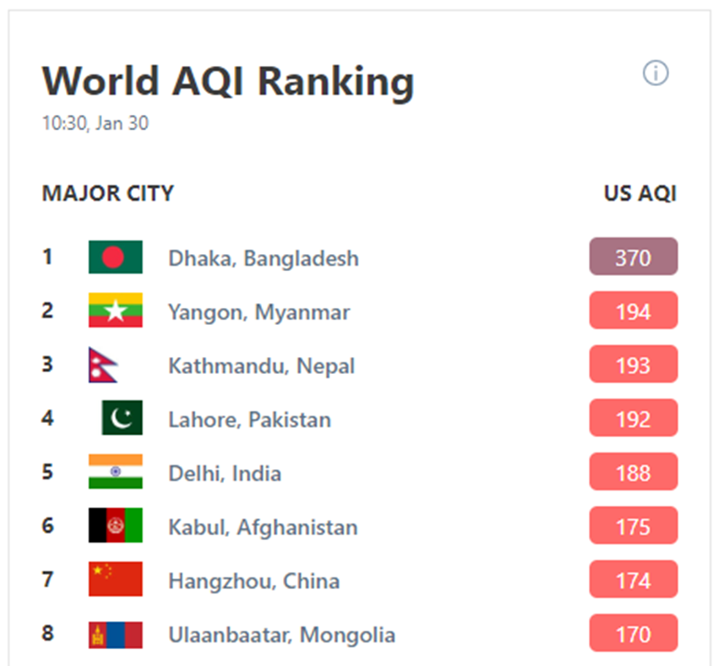

All the ranges are assigned a color code with general standardized public health advice and descriptions by the AQI.

